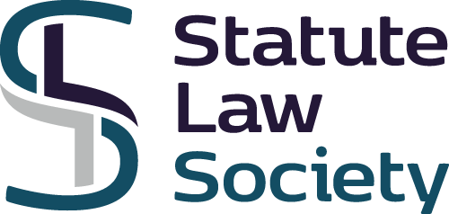

APPLICATION FOR MEMBERSHIP

Annual subscription:
Individual £25; Institution £150

Title:
First name:
Surname:
Address:
Tel:

Email:

Professional Qualifications:

Present employment:

Areas of particular interest:

Date:

PAYMENT:
- Cheque payable to The Statute Law Society and sent to
27 Hervey Park Road, London E17 6LJ

- BACS Payment to The Statute Law Society, Sort Code 60-00-01 (NatWest)
A/c No. 00274704 IBAN GB59 NWBK 6000 0100 2747 04

To keep administrative costs to a minimum we encourage members to set up an annual Standing Order to the Association.

